Input | Distribution | Parameters
Prob attending day 1  Prob attending day 2 | 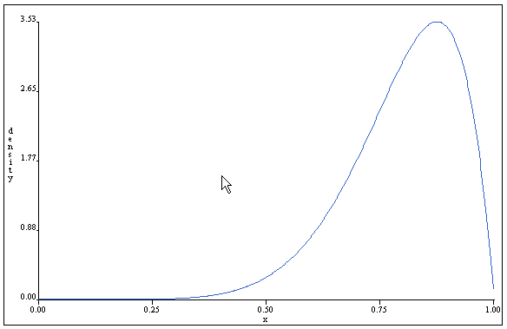 | beta(8,2)  mean = 80%
Prob attending day 3 | 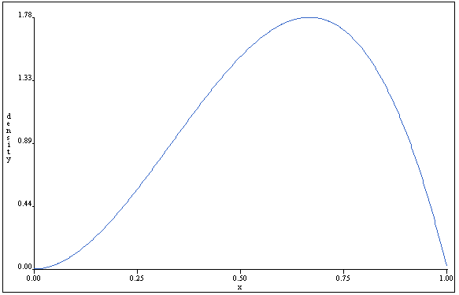 | beta(3,2)  mean = 60%
prob attending plenary/forum sessions  prob attending issues panel | 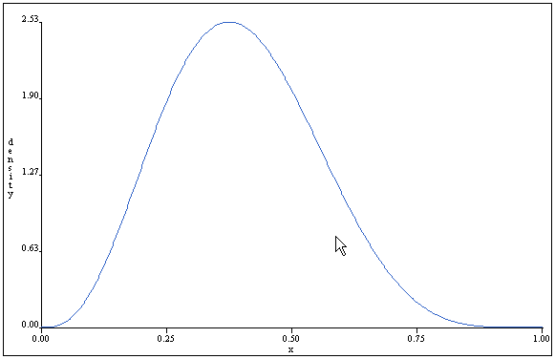 | beta(4,6)  mean = 40%
prob attending workshop  prob attending research session | 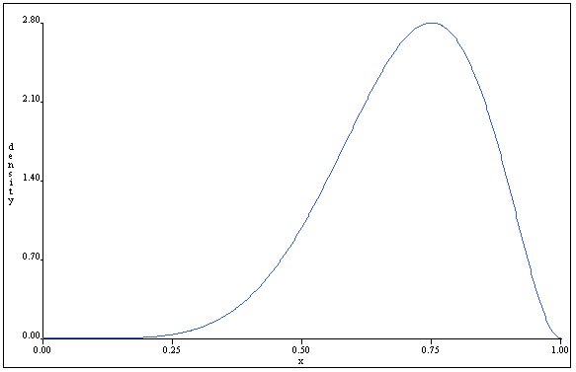 | beta(7,3)  mean = 70%
prob handouts @ plenary session  prob handouts @ issues panel  prob handouts @ forums | 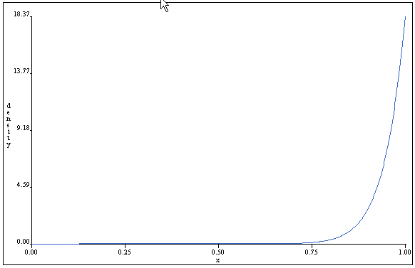 | beta(19,1)  mean = 95%
prob handouts @ workshop |  | beta(8,2)  mean = 80%
prob handouts @ research session | 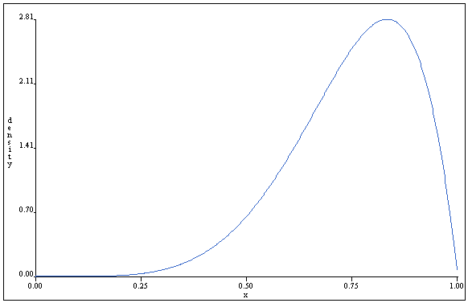 | beta(6,2)  mean = 75%
prob take handout | 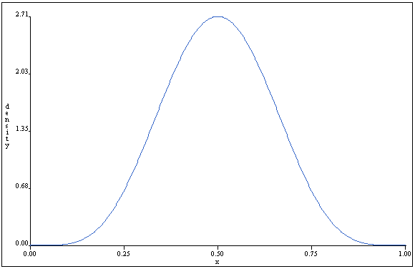 | beta(6,6)  mean = 50%

Day 1 sessions
- Plenary session
- Issue panel
- Podium presentation
- Podium presentation
- Workshop
- Forum

Day 2 sessions
- Podium presentation
- Plenary session
- Issue panel
- Workshop
- Workshop
- Forum

Day 3 sessions
- Workshop
- Issue panel
- Workshop
- workshop

